A Work Breakdown Structure for Implementing and Costing an ERP Project

Aisha Momoh, Decision Engineering Centre, Cranfield University, Bedford, [UK,a.momoh@cranfield.ac.uk](mailto:UK%2Ca.momoh@cranfield.ac.uk) Rajkumar Roy, Decision Engineering Centre, Cranfield University, Bedford, UK, [r.roy@cranfield.ac.uk](mailto:r.roy@cranfield.ac.uk) Essam Shehab, Decision Engineering Centre, Cranfield University, Bedford, [UK,e.shehab@cranfield.ac.uk](mailto:UK%2Ce.shehab@cranfield.ac.uk)

Abstract

This paper presents a Work Breakdown Structure (WBS) for a phased implementation of an Enterprise Resource Planning (ERP) solution. The key activities that constitute an ERP implementation project are discerned in detail, each in its entirety. Each activity illustrates the tasks required to fulfill each part of a project. The potential challenges that are usually encountered in every selected activity are discussed. Finally, using a WBS to cost an ERP project is proposed.

Keywords: Work Breakdown Structure; WBS; ERP; Project Activities

1. Introduction

ERP has been referred to as a business operating system that enables better resource planning and improved delivery of value-added products and services to customers [10]. They automate core corporate activities such as manufacturing and the management of financial, and human resources and the supply chain [10]. Major business drivers behind ERP implementations are: improving productivity, providing competitive advantage, and satisfying customer demands [5].

Although ERP applications have been widely adopted by a variety of industries worldwide, the challenges faced during and post-implementation remain a growing concern. ERP systems are complex pieces of software [5]. Consequently, many such implementations have been difficult, lengthy and over budget, were terminated before completion, and failed to achieve their business objectives even a year after implementation [5]. Researchers and practitioners alike are still in the process of studying and understanding the causes of these hurdles. As part of this research, an in-depth literature review highlighted numerous project challenges. Based on the Risk Factors of ERP, one of the risks identified in project management and control, is a lack of effective project management methodology [4]. However, very little is mentioned about ERP project planning methodologies

in research. Based on the primary author’s in-depth experience in ERP implementations, predominantly SAP, she recognizes that some project methodologies are not detailed enough. Regardless of how effective a methodology may appear, should it lack the relevant detail, the project in question may not yield the anticipated success. In order to achieve a successful implementation, this paper proposes the use of a work breakdown structure (WBS) to guide an ERP project.

A Work Breakdown Structure is a project management tool. It is defined as an enumeration of all work activities in hierarchic refinement of detail which organizes work to be done into short manageable tasks with quantifiable inputs, outputs, schedules, and assigned responsibilities [14]. A WBS is also used for project costing. This paper discusses using a WBS to organize an ERP project,

Literature review reveals that ERP implementations are fraught with numerous problems. ERP implementations are notorious for taking a longer time and taking more money than is projected [12]. Most of the literature studied indicates a variety of issues inherent in executing an ERP project. However, there is hardly any mention of failures based on poor project planning and methodology. Based on in-depth ERP experience and use of various project methodologies, the primary author recognizes that several projects fail as a consequence of poor planning. This area requires significant attention.

2. Research Methodology

The methodology that was employed in this research was based on the following:

• Information gathered on company-specific project methodologies, ERP implementations, Accelerated SAP (ASAP) project methodology used in SAP R/3 projects and Work Breakdown Structures based on primary author’s ERP project experience.

• Literature review on ASAP

• Identifying project activities that are excluded from ASAP based on knowledge of company-specific project methodologies.

• Using a WBS to amalgamate the identified project activities with the ASAP project activities

• Based on literature review of ERP challenges and previous case study, identifying challenges associated with each project activity in the WBS.

3. ASAP Project Methodology

SAP introduced the ASAP implementation methodology with the goal of speeding up SAP implementation projects [9]. ASAP implementation is a structured implementation approach that can help managers achieve a faster implementation with quicker user acceptance, well-defined roadmaps, and efficient documentation at various phases [9]. The ASAP methodology phases are [9]:

• Project preparation – the purpose of this phase is to provide initial planning and preparation of the SAP project. The steps of this phase help identify and plan the primary focus areas to be considered such as: objectives, scope, plan and definition of project team. The outcome is the project charter.

• Business blueprint – the purpose of this phase is to create the business blueprint, which is a detailed documentation of the organizational structure and business processes gathered during requirements workshops/meetings. It will allow the implementation project team to clearly define their scope, and only focus on the SAP processes needed to run the organization business.

• Realisation – the purpose of this phase is to actually configure SAP R/3 based on the specifications of the business blueprint as well as taking further input into account (Questions and Answer database). The objective is the final configuration of the

system, an overall test, and the release of the system for live operation.

• Final preparation – the purpose of this phase is to complete the final preparation, including testing, end user training, system management and cutover activities. The final preparation phase also serves to resolve all open issues.

• Go live and support – the purpose of this phase is to move from a pre-production environment to live operation. A support organization must be set up for end users to provide long-term support. This phase is also used to monitor system transactions and to improve overall system performance. Finally, the completed project is closed.

Each phase is composed of a group of work packages [9]. These work packages are structured in activities, and each activity is composed of a group of tasks [9]. For each task, a definition, a set of procedures, results and roles are provided in the ASAP methodology documentation [9]. Implementations where ASAP or Powered by SAP methodologies were used averaged only 8 months, compared to 15 months for standard implementations [9].

4. Work Breakdown Structure for ERP Implementation

A complex project is made manageable by first breaking it into individual components in a hierarchical structure, known as Work Breakdown Structure [13]. Such a structure defines tasks that can be completed independently of other tasks, facilitating resource allocation, assignment of responsibilities, and measurement and control of the project [13].

This section depicts the use of a WBS in Figures 1, 1a and 1b to plan an ERP project. The various levels in the WBS are illustrated in Table 1.

Fig 1. WBS for ERP Implementation

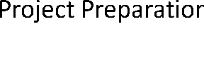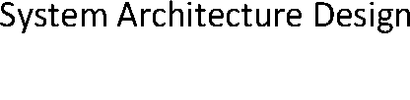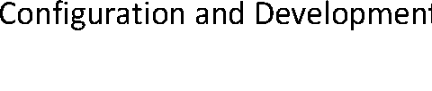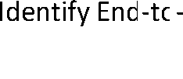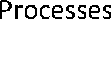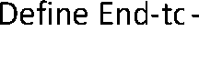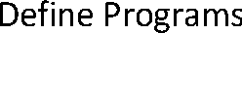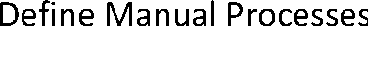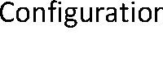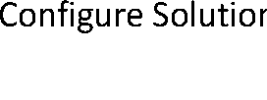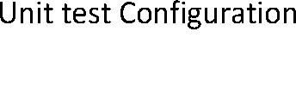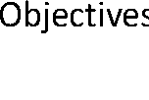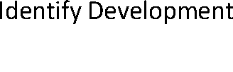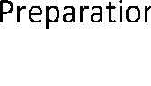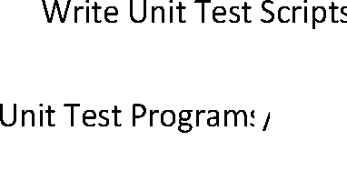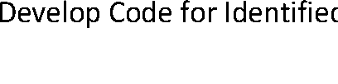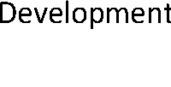

Fig 1a. WBS for ERP Implementation

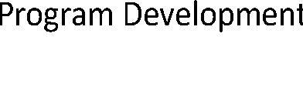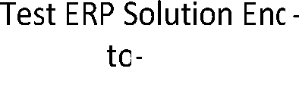

Fig 1b. WBS for ERP Implementation

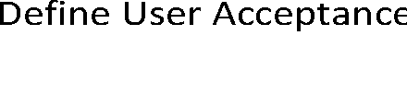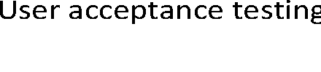

Table 1 below illustrates the various levels of project activity in the WBS structures above. Each organization uses its own terminology for classifying WBS components according to their level in the hierarchy [13]. For example, some organizations refer to different levels as tasks, sub-tasks and work

packages, whilst others use the terms phases, entries and activities [13]. In this paper, activities are used to classify the WBS components. The nodes (in circles) A and B indicate continuation of the activities linked

to these nodes

Table 1: WBS Component Levels

|  |  |  |  |
| --- | --- | --- | --- |
| Project | First Level  Activity | Second Level Activity | Third Level Activity |
| ERP  Implementation | Project Preparation | Define Project Scope and  Objectives |  |
|  |  | Identify Project Team |  |
|  |  | Identify Stakeholders |  |
|  | System  Architecture  Design | Identify System Environment | Technical Infrastructure  Preparation |
|  |  |  | Identify Development  Environment |
|  |  |  | Identify Quality  Assurance Environment |
|  |  |  | Identify Training  Environment |
|  |  |  | Identify Production  Environment |
|  | Business Blueprint | AS-IS Business Process  Analysis | Identify End-to-End  Current Business  Processes |
|  |  |  | Identify Process  Integration Points |
|  |  | Map ERP Processes to  Business Processes |  |

|  |  |  |  |
| --- | --- | --- | --- |
| Project | First Level  Activity | Second Level Activity | Third Level Activity |
|  |  | Define TO-BE Processes | Define End-to-End  Future Business  Processes |
|  |  | Identify Gaps |  |
|  |  | Propose Gap Solution | Define Reports |
|  |  |  | Define Programs |
|  |  |  | Define Interfaces |
|  |  |  | Define Manual  Processes |
|  |  | Document Blueprint |  |
|  |  | Sign Off Blueprint |  |
|  | Configuration and  Development | Configure Solution | Write Unit Test Scripts |
|  |  |  | Configure Solution |
|  |  |  | Unit test Configuration |
|  |  | Develop Code for Identified  Gaps | Write Technical  Specifications |
|  |  |  | Write Unit Test Scripts |
|  |  |  | Unit Test  Programs/Reports/Interf aces |
|  |  | Sign Off Configuration and  Development |  |
|  | Define  Authorizations | Define Roles in Organisation |  |
|  |  | Identify Roles for Use of  ERP |  |
|  |  | Define Authorisations |  |
|  |  | Test Authorisations |  |
|  |  | Sign Off Authorisations |  |
|  | Data Conversion | Define Fields in ERP  Solution |  |
|  |  | Map ERP Fields to Legacy  System Fields |  |
|  |  | Convert Legacy Fields to  ERP Fields |  |
|  |  | Define Data for Cleansing |  |
|  |  | Cleanse Data |  |
|  |  | Sign Off Data Cleansing |  |
|  | Data Migration  Program  Development | Develop Migration Program |  |
|  |  | Unit Test Migration Program |  |
|  |  | Sign Off Data Migration  Program |  |
|  | System Testing | Define Test Scripts |  |
|  |  | Test ERP Solution End-to-  End |  |
|  |  | Sign Off System Tests |  |
|  |  |  |  |
|  | Training | Define Business Processes  Based on Roles |  |

|  |  |  |  |
| --- | --- | --- | --- |
| Project | First Level  Activity | Second Level Activity | Third Level Activity |
|  |  | Document Training |  |
|  |  | Train Users on Business  Processes |  |
|  |  | Train Users on ERP |  |
|  | User Acceptance  Testing | Define Business Scenarios |  |
|  |  | User Acceptance Test  Documents | Create Fault Report  Sheet |
|  |  | Define User Acceptance Test  Scripts |  |
|  |  | Test ERP functionality |  |
|  |  | Sign Off |  |
|  | Cutover | Migrate Cleansed Data |  |
|  |  | Go Live |  |
|  |  |  |  |

5. WBS Activities and Potential Challenges

The WBS project activities in table 1 will be described in this section. They have been derived from the ASAP project methodology, literature review on project methodologies and SAP implementation experience. Certain activities that are already embedded as sub-tasks in ASAP project activities are illustrated as First Level activities for transparency and more effective planning. Such activities are System Architecture Design, Define

Authorizations, Data Conversion, Data Migration Program Development, System Testing, Training, and User Acceptance Testing. First Level activities will be the focus of this section as well as the potential challenges that could emerge during the execution of each activity.

Project Preparation

This activity has been defined in section 4 of this paper. Some of the challenges that may present themselves in project management and control, which is part of project preparation, are: (i) lack of agreement on project goals, (ii) lack of senior management involvement, and (iii) a lack of effective project management methodology [4].

System Architecture Design

The essence of this activity is to agree on and define the environment upon which the ERP application will be installed. At this stage, the environments in which the application will be configured, quality assured and operate in a live situation are also critical considerations. Furthermore, even though the project

team is not responsible for the technical infrastructure, it is essential that it is flagged in the WBS as a dependency.

Potential challenges in this activity are: (i) unavailability of technical infrastructure, (ii) technology complexity[4], (iii) failure in attempt to link legacy applications, (iv) and minimal understanding of architecture requirements and design.

Business Blueprint

This activity has been described in section 4 of this paper. Some of the likely potential challenges during the execution of this activity are: (i) minimal understanding of business processes, (ii) business requirements to customize the ERP application beyond its standard functionality, (iii) lack of business process reengineering, (iv) employee resistance to change, (v) use of inexperienced consultants, and (vi) minimal understanding of the ERP application functionality. Further challenges are being unable to comply with the standard which ERP software supports, and a lack of integration between enterprise- wide systems [4].

Configuration and Development

This activity is equivalent to the Realisation part of the ASAP methodology. It involves configuring the ERP application based on the business blueprint. It is essential the application is configured using to the standard functionality in the system. Other activities under the umbrella of this main activity are the development of reports, interfaces and additional programs.

Some of the likely challenges in this activity are: (i) unclear and misunderstanding of changes in requirements, (ii) lack of an effective methodology, and (iii) poor estimation and failure to perform the activities needed [4]. Customization is usually associated with increased IS costs, longer implementation time, and the inability to benefit from vendor software maintenance, and upgrades [5]. Another key challenge is a lack of understanding of the ERP application by the consultants. Additionally, lack of resources represents a major concern in ERP implementation [5].

Define Authorizations

The purpose of this activity is to define the roles of the respective ERP application users once the application has gone live. These roles will be used to define access rights for each of the users. This way, unauthorized users will not be allowed access to information in the ERP application that is not within their jurisdiction. The main challenge in this activity is incorrect definition of roles and authorizations.

Data Conversion

This activity involves converting the format of the data in the legacy system to suit the data format of the ERP system. This process also entails cleansing the data in the legacy system. This means that the users will filter through the data in their old system, and eradicate any discrepancies.

A fundamental requirement for the effectiveness of ERP system is the availability and timeliness of accurate data [5]. They further advise that the management of data entering the system is a critical issue throughout system implementation. Data-related challenges include finding the proper data to load into the system and converting disparate data structures into a single, consistent format before system use [5].

Data Migration Program Development

The Data Migration Program Development activity involves coding the program that will transfer the data from the legacy system to the ERP application. Potential challenges that could be presented during the execution of this activity are: (i) lack of coding skills, and (ii) improperly defined data.

System Testing

System Testing entails the consultants that implemented the ERP application ensuring that the system works end-to-end. The entire system is tested, process by process across all functions of the system.

The type of challenges that may be faced during system testing are: (i) discovering that a substantial amount of the configured functionality does not meet business requirements, (ii) allowing scope creep due to sudden changes, (iii) the tendency to carry on testing beyond its specified, and (iv) lack of understanding of the ERP application.

Training

Training involves imparting knowledge of the implemented solution to the users before the system goes into live operation. This activity entails defining business processes for the respective roles and defining business scenarios to suit these processes. These scenarios enable the users to understand the system functionality better.

Insufficient training of end users could be a potential challenge during the Training exercise [4]. Other potential challenges are: (i) lack of user commitment and ineffective communication with users, and (ii) conflicts between user departments [4].

User Acceptance Testing (UAT)

This activity involves the users whom will utilize the ERP application in a live environment, ensuring that all the business requirements are met in the system and are functional. The users define business scenarios for testing.

Potential challenges in UAT are: (i) lack of user training, (ii) lack of understanding of the business processes and requirements, and (iii) resistance to change.

Cutover

This activity means going live by migrating from the legacy system to the ERP application. This application becomes operational in a live environment. It involves migrating live data from the legacy system to the new system.

Typical challenges that may be presented whilst executing this activity are: (i) unavailability of a complete set of data for migration, (ii) failure of data migration program, (iii) unavailability of operational environment for data to be migrated into, and (iv) lack of business readiness.

6. Discussions and Conclusion

Researchers and practitioners concede that ERP implementations are fraught with problems. Literature review reaffirms this fact, and illustrates a

variety of ERP implementation challenges. However, not much is mentioned about poor project planning being one of the challenges encountered in ERP project execution. The methodologies used in project planning and the way that they are used go a long way in determining the success or failure of a project.

A good project methodology known as ASAP, which is used in SAP implementations, was studied. However, in order to ensure that all aspects of an ERP implementation are addressed, it is advisable to extend ASAP and other methodologies into a WBS. The WBS will be used to define the ERP project activities so that the lowest level of activity is accounted for. This paper illustrated the use of a WBS in defining project activities. Additionally, based on a previous case study and literature review, the challenges that likely to be encountered in ERP implementations were highlighted. Going forward, further research should be conducted to link these challenges to the WBS using a Risk Breakdown Structure (RBS). This exercise will guide an organization implementing ERP against the potential risks that are likely in project activities.

A further area for research is the costing of ERP project activities using a WBS. This will guide organizations in preparing realistic budgets for their ERP implementations.

7. References

[1] Kovacs, G.L., Paganelli, P. “A Planning and Management Infrastructure for Lare, Complex, Distributed Projects – Beyond ERP and SCM”, Computers in Industry (51), 2003, pp. 165-183.

[2] Wei, C., Wang, M.J. “A Comprehensive Framework for Selecting an ERP System”, International Journal of Project Management (22),

2004, pp. 161-169.

[3] Labuschagne, C., Brent, A.C. “Sustainable Project Life Cycle Management: the Need to Integrate Life Cycles in the Manufacturing Sector”, International Journal of Project Management (23), 2005, pp. 159-

168.

[4] Huang, S., Chang, I., Li, S., Lin, M. “Assessing Risk in ERP Projects: Identify and Prioritize the Factors”, Industrial Management & Data Systems (104:8), 2004, pp. 681-688.

[5] Somers, T.M., Nelson, K.G. “A Taxonomy of Players and Activities Across the ERP Project Life Cycle”, Information and Management (41), 2004, pp.

257-278.

[6] Daneva, M. @Lessons Learnt from Five Years of Experience in ERP Requirements Engineering”, Proceedings of the 11th IEEE International Requirements Engineering Conference, 2003.

[7] Gable, G.G., Scott, J.E., Davenport, T.D. “Cooperative ERP Life-Cycle Knowledge Management”, Proceedings of the Ninth Australian Conference on Information Systems, September – October 1998, pp. 227-240.

[8] Leopoulos, V., Kirytopoulos, K., Voulgaridou, D. “ERP Systems as a Component of the Electronic Supply Chain: Classification of Implementation Risks”, Proceedings of the 2005 International Conference on computational Intelligence for Modelling, Control and Automation, and International Confe Intelligent Agents, Web Technologies and Internet Commerce, 2005.

[9] Esteves, J., Chan, R., Pastor, J., Rosemann, M. “An Exploratory Study of Knowledge Types Relevance Along Enterprise Systems Implementation Phases”, 4th European Conference on Organizational Knowledge and Learning Capabilities, April 2003.

[10] Chang, S. “ERP Life Cycle Implementation, Management and Support: Implications for Practice and Research”, Proceedings of the 37th Hawaii International Conference on System Sciences, 2004.

[11] Esteves, J., Pastor, J.A. “A Framework to Analyse Most Critical Work Packages in ERP Implementation Projects”, International Conference on Enterprise Information Systems, 2002.

[12] Mabert, V.A., Soni, A., Venkataramanan, M.A. “Enterprise resource planning survey of US manufacturing firms”, Production and Inventory Management Journal (41:2), 2000, pp. 52-58.

[13] Work Breakdown Structure. Retrieved June 7, 2008,

from:

//[www.netmba.com/operations/project/wbs/](http://www.netmba.com/operations/project/wbs/)

[14] Tausworthe, R.C. The Work Breakdown

Structure in Software Project Management. Retrieved June 8, 2008, from://md1.csa.com/partners/viewrecord.php?requeste r=gs&collection=TRD&recid=A8133550AH&q=Wor k+Breakdown+Structure+Tausworthe&uid=79289263

1&setcookie=yes

Copyright © 2008 by the International Business Information Management Association (IBIMA). All rights reserved. Authors retain copyright for their manuscripts and provide this journal with a publication permission agreement as a part of IBIMA copyright agreement. IBIMA may not necessarily agree with the content of the manuscript. The content and proofreading of this manuscript as well as and any errors are the sole responsibility of its author(s). No part or all of this work should be copied or reproduced in digital, hard, or any other format for commercial use without written permission. To purchase reprints of this article please e-mail: [admin@ibima.org.](mailto:admin@ibima.org)